**Experiment 2**

**Aim:** Down Sampling and Up Sampling an image

**Code for down sampling:**

from skimage import io

import matplotlib.pyplot as plt

image = io.imread ("C:/Users/dhruv/Desktop/face.png")

io.imshow (image)

img_down = image.copy ()

sh = image.shape

print (sh)

ds = 5

rowd = int(sh[0]/ds) +1

cold = int(sh[1]/ds) +1

img_down = img_down[0:rowd,0:cold]

sh = image.shape

print (sh)

rw=0

cl=0

for r in range (0,sh[0],ds):

cl=0

for c in range (0,sh[1],ds):

img_down [rw][cl]= image[r][c]

cl += 1

rw += 1

sh1 = img_down.shape

print (sh1)

plt.figure()

plt.figure(figsize=(10,10))

plt.subplot(1,2,1)

io.imshow (image)

plt.title ('Original Image')

plt.subplot(1,2,2)

io.imshow (img_down)

plt.title ('Down sampled Image')

**Outputs:**

ds=5

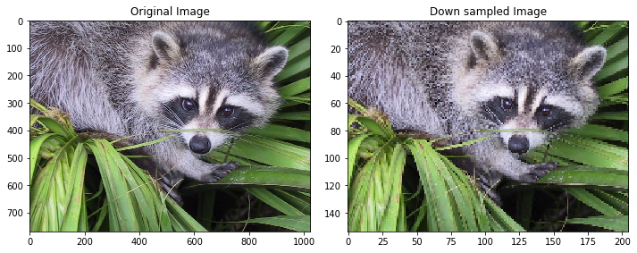

ds=10

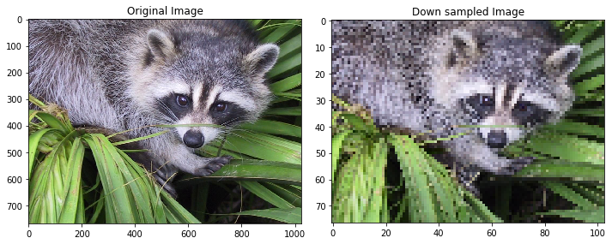

ds=25

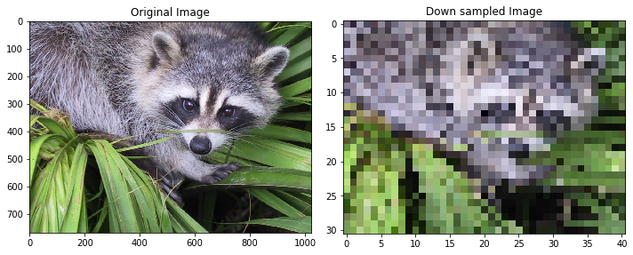

**Code for up sampling:**

up = 5

img_up = image.copy()

sh = img_down.shape

r=0

c=0

for row in range (0,sh[0]):

c=0

for col in range (0,sh[1]):

img_up[r][c]=img_down[row][col]

img_up [r,c+1:c+up] = 0

c+=up

img_up [r+1 : r+up, :] = 0

r+=up

shu = img_up.shape

#use average method of interpolation

#for columns

for row in range (0,shu[0],up):

for col in range (0,shu[1]-up,up):

temp1 = img_up[row,col]/2

temp2 = img_up[row,col+up]/2

temp = temp1 + temp2

img_up [row,col+1 : col+up] = [int(temp[0]),int(temp[1]),int(temp[2])] #for RGB

#for rows

for row in range (0,shu[0]-up,up):

for col in range (0,shu[1]):

temp1 = img_up[row,col]/2

temp2 = img_up[row+up,col]/2

temp = temp1 + temp2

img_up [row:row+up,col] = [int(temp[0]),int(temp[1]),int(temp[2])]

plt.figure()

plt.figure(figsize=(10,10))

plt.subplot(1,3,1)

io.imshow (image)

plt.title ('Original Image')

plt.subplot(1,3,2)

io.imshow (img_down)

plt.title ('Down sampled Image')

plt.subplot(1,3,3)

io.imshow (img_up)

plt.title ('Up sampled Image')

**Outputs:**

Before Average Interpolation:

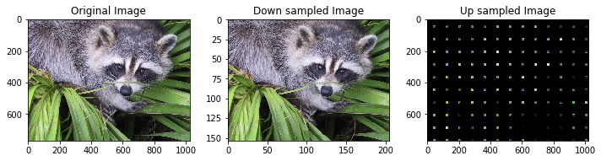

After Average Interpolation:

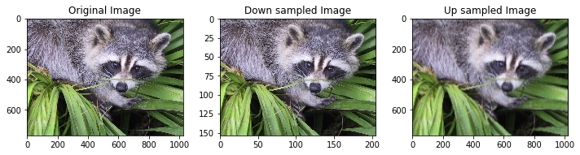

**Conclusion:**

1. Down Sampling reduces the size of the image in terms of columns and rows.
2. As we increase the rate of down sampling, the quality of the image deteriorates.
3. For up sampling, if additional rows and columns are replaced by 0, then the quality of image worsens.
4. If additional rows and columns are replaced by the average of neighboring pixels, then the quality of image improves.
5. Quality of up sampled image can be further improved by using bilinear or cubic interpolation.